How to Draw a Mountain Vista
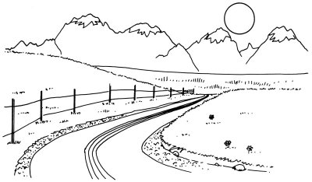

A paved road leads to a range of snow-capped mountains, gleaming in the sun, in this landscape. You can almost smell the crisp winter air when gazing at this scene.

In this section, we'll show you how to draw this mountain vista landscape. You can draw it freehand while looking at your computer monitor, or you can print out this page to get a closer look at each step.

Here, we'll show you an illustration of each step and then give you a description of how to draw it. Follow the red lines in each illustration to learn exactly what to draw in that step. The lines drawn in previous steps are shown in gray.

To draw the mountain vista landscape, lightly draw a line across the page for the horizon.


Step 1: Lightly draw a line across the page for the horizon. Place it about one-third of the way from the top. Add four curving lines, beginning from the lower center of the page and running first to the left and then sharply to the right. Show that the road goes off into the distance by bringing the lines closer together at the top. This use of lines that come together to show depth is known as perspective.

To draw the mountain vista landscape, draw inverted V-shapes using jagged lines to show a distant range of mountains.

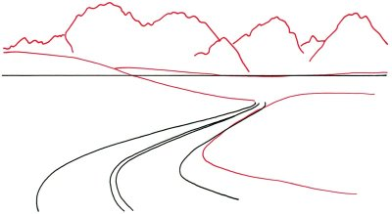
Step 2: Draw inverted V-shapes using jagged lines to show a distant range of mountains. Alter the horizon line with curved lines to look like gently rolling hills. Create another hill with a lazy curve to the right of the center.

To draw the mountain vista landscape, add grass on the hillsides and near the road.

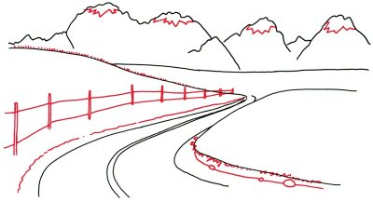
Step 3: Draw sharply jagged lines for snow caps on the tops of the highest mountains. Add grass on the hillsides and near the road with many slanted and jagged lines. Make a series of narrow fence posts with double vertical lines, making them smaller as they fade off toward the end of the road. Use nearly straight lines to show fence rails. Sketch the edge of the road with squiggly lines. Draw rocks near the road with irregular ovals.

To draw the mountain vista landscape, sketch a circular sun in the sky.

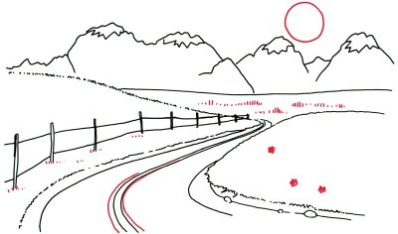
Step 4: Draw a circular sun in the sky, then put in some tall grass in the middle distance with short lines. Use more short lines for clumps of low grass along the fence. Scatter a few daisylike flowers on the hillside. Add two more curved lines in the center of the road.

To finish your mountain vista landscape, add further details to the shoulder area at the edge of the road.

Step 5: Finish this sketch by adding further details to the shoulder area at the edge of the road. Use plenty of dots and short, squiggly lines to look like rocks and gravel. Place more grass on the hills to the left and right sides using a mixture of short lines, straight and jagged.

Your landscape drawing is finished!

